**Assignment 6: Monitor and Alert High AWS Billing Using AWS Lambda, Boto3, and SNS**

**1: SNS Setup**

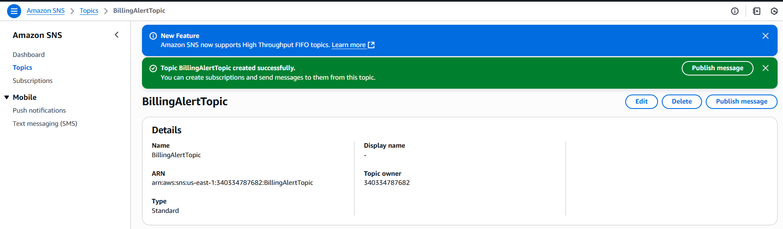

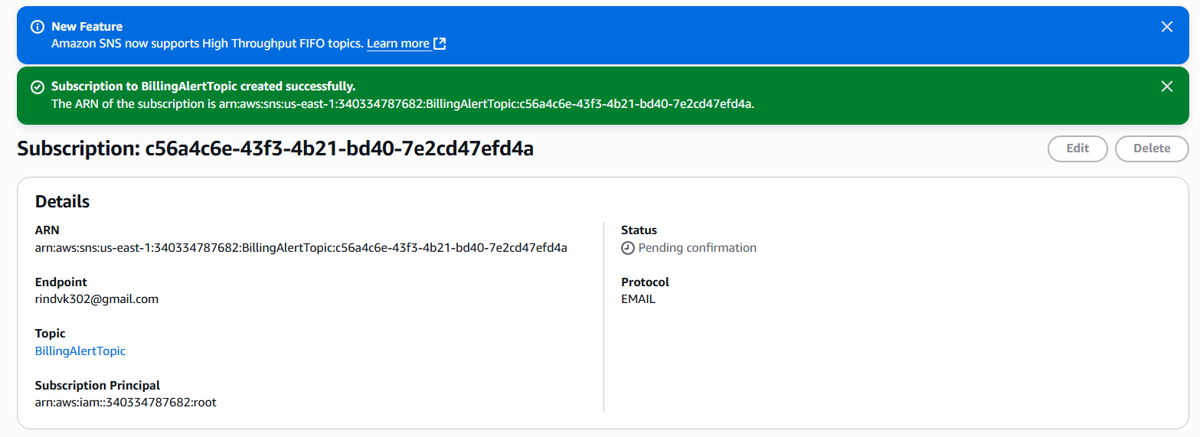

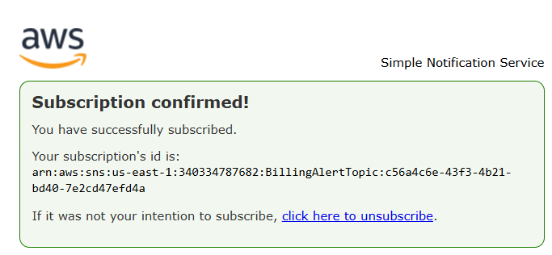

**2: Create IAM Role for Lambda**

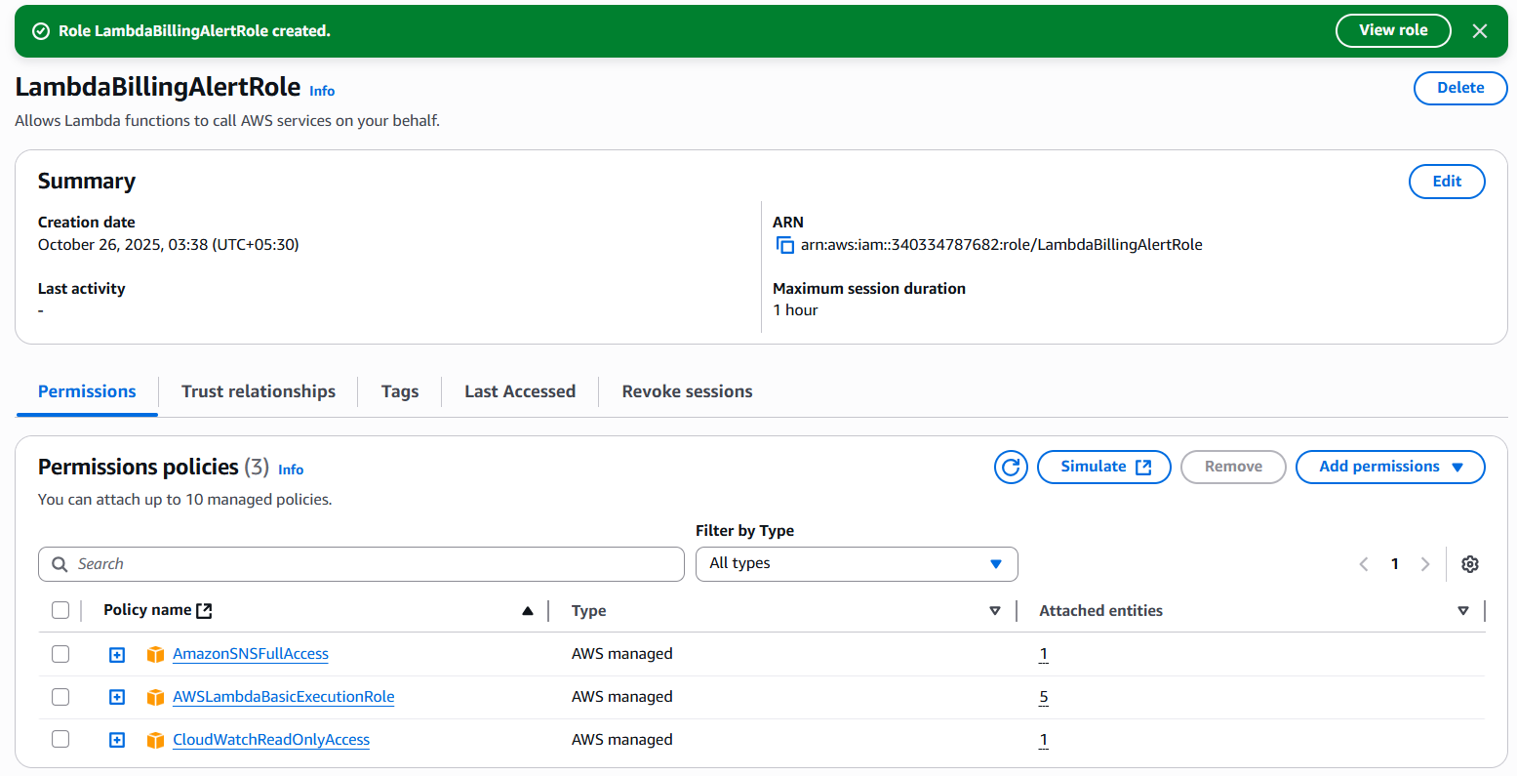

**3: Create the Lambda Function**

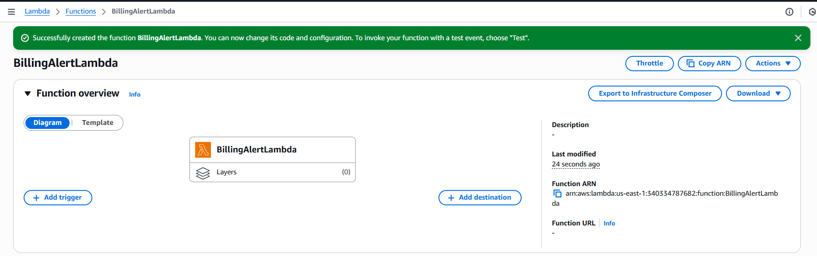

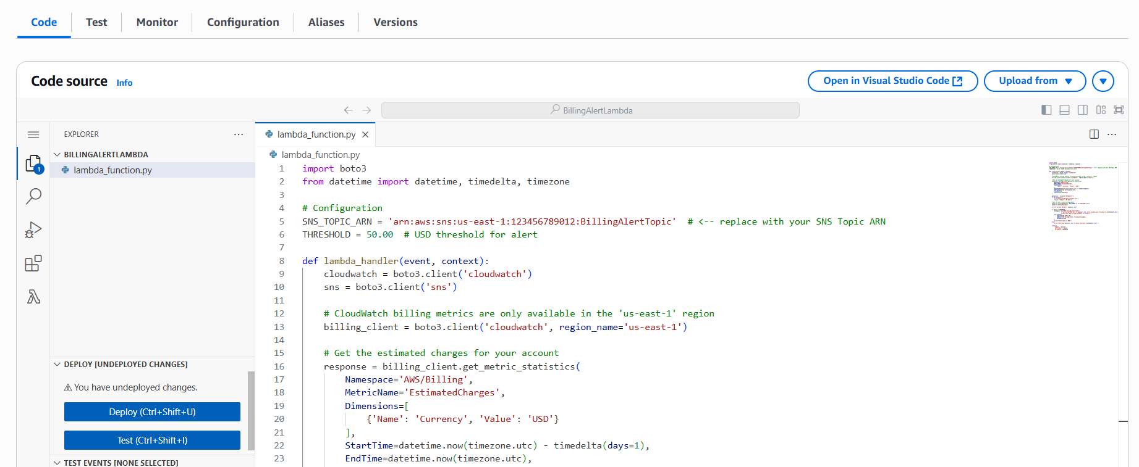

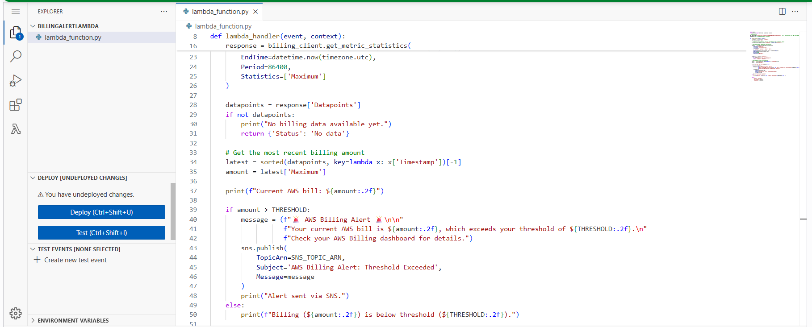

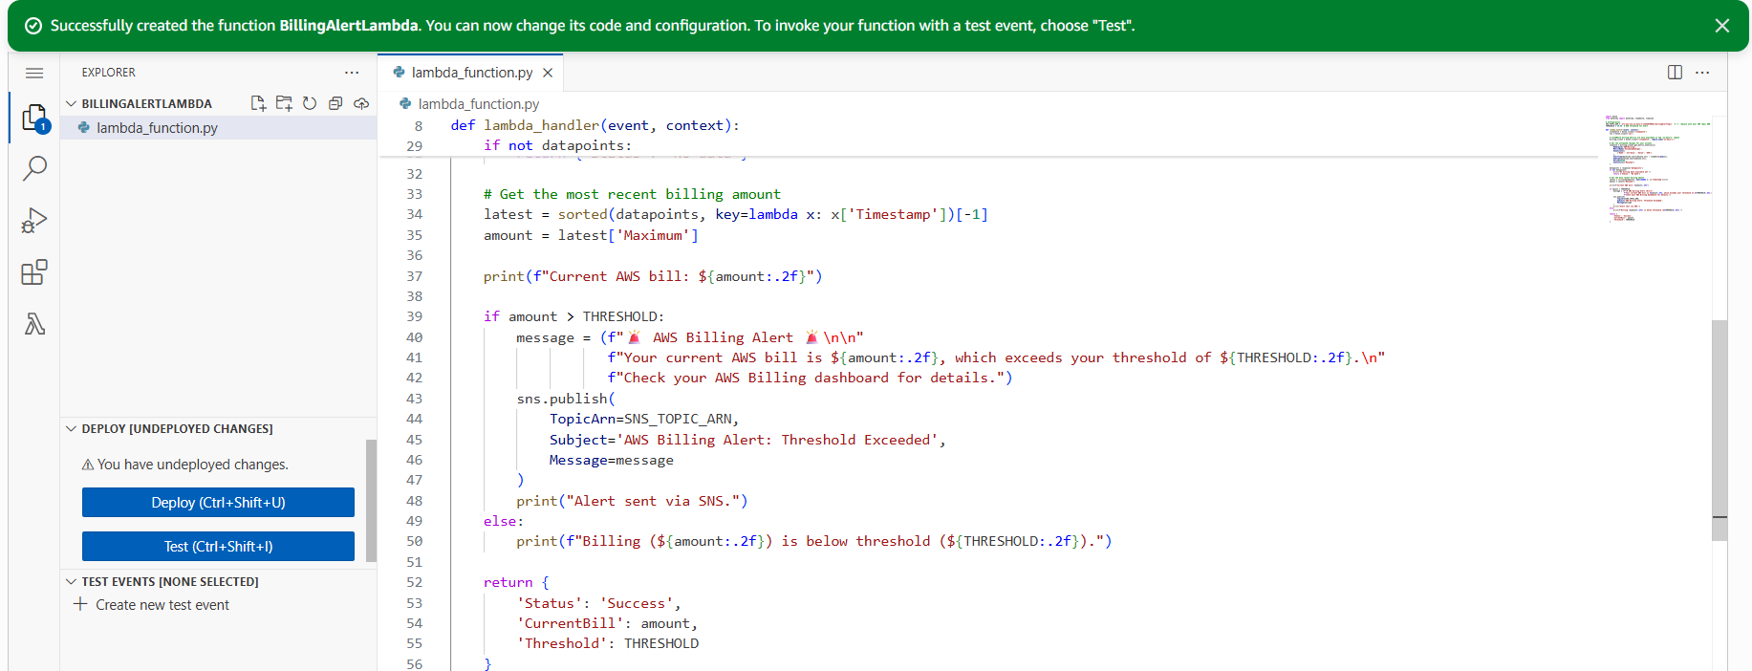

**4: Test the Lambda Function**

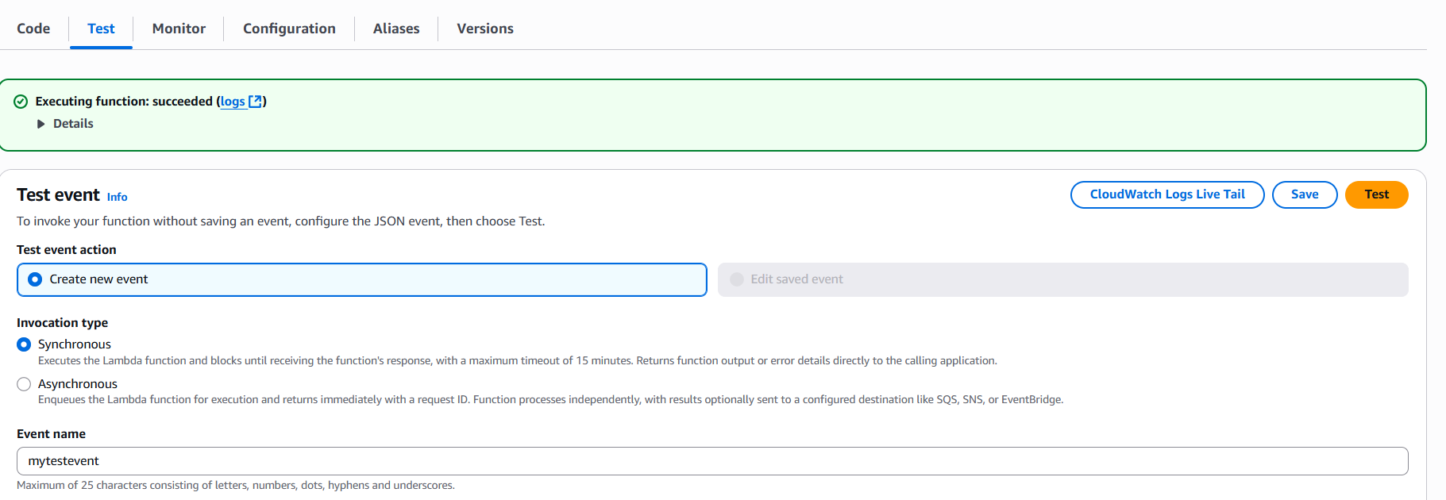

**5: Automate the Check (EventBridge Rule)**

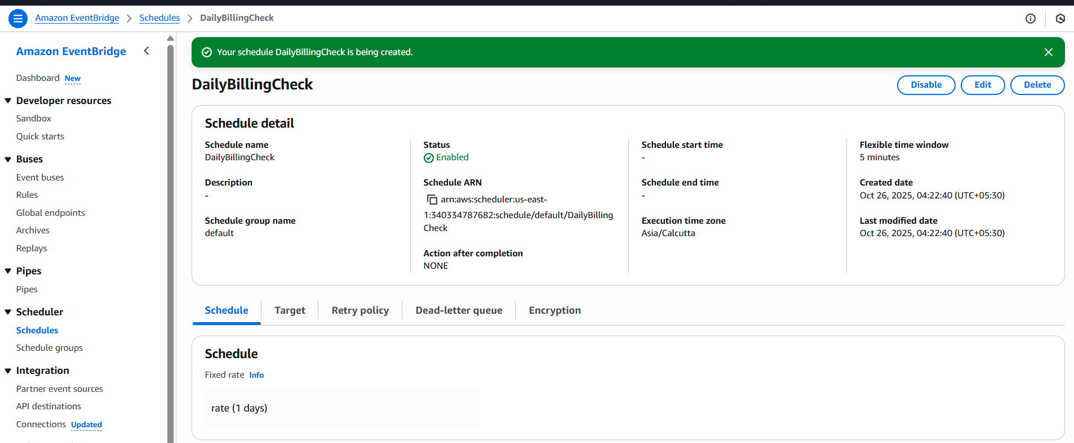

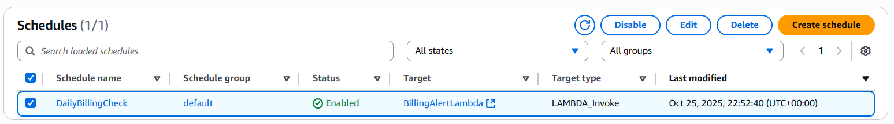

**6: Verify Alerts**

